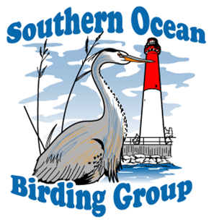

SOUTHERN OCEAN BIRDING GROUP
MEMBERSHIP APPLICATION

First Name(s) Last Name

__________________________________ ________________________________________

Street Address 1 Street Address 2

___________________________________ ________________________________________

City State Zip Code

___________________________________ ____________ ________________________

Phone E-mail Address

_(______)____________________________ ________________________________________

Cell Phone Date

_(_____)_____________________________ ________________________________________

New Member _______________ Renewal_____________

ANNUAL MEMBERSHIP LEVEL:

__________________ Single Membership: $25

__________________ Couple Membership $40

__________________ Student Membership (FULL-TIME STUDENTS No Charge for Membership)

Cash__________ Check Number_________________________

Are you interested in joining a committee? _______________Yes _______________No

Program Committee _________________ Field Trip Committee ________________________

Membership Committee ______________ Newsletter Committee ________________________

Fundraising Committee _______________

Mail to: Membership Chair, Jeanine Apgar, 206 N. Frankfurt Ave., Egg Harbor City, NJ 08215 .

